Lab 5 CCS3101
2 May 2025
- Solve the following question and demonstrate your solution to me in this lab (preferred) or at the start of the next lab. For record-keeping, submit also your solution and screenshots of its output to PutraBlast.
- Evaluation will be done according to the lab rubric on PutraBlast. I will ask questions accordingly.
*******************************

Questions 12.2 and 12.6:

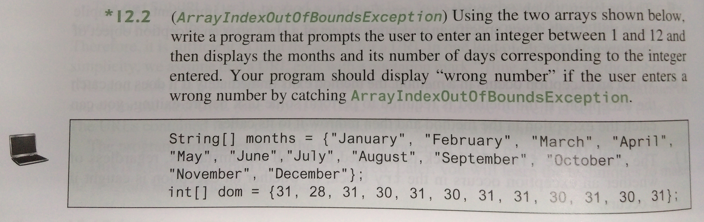

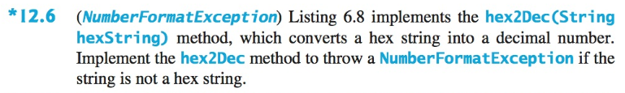

Listing 6.8 is as follows.

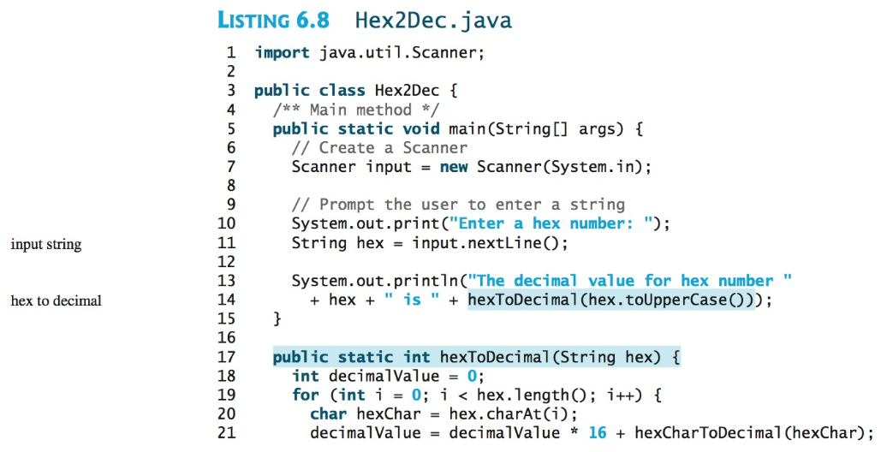

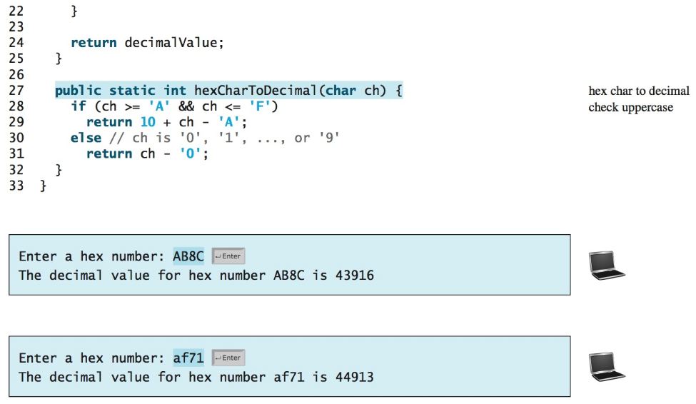

(Question 12.2 is from the 11th edition of the Liang textbook. The other question and the code are from the 10th edition of the same textbook. The corresponding question and code in the 11th edition are the same, as far as I know).

